|  |
| --- |
| **Database Systems Lab (CL2005)** |
| Date: March 19th 2025 |
| **Instructor(s)** |
| Mr. Muhammad Kamran |

|  |  |
| --- | --- |
| **Sessional Exam** | |
| **Total Time (Hrs):** | **1.5** |
| **Total Marks:** | **40** |
| **Total Questions:** | **4** |

|  |
| --- |
| _____________________ _____________________  Roll No Section Student Signature |

**Do not write below this line**

**Attempt all the questions.**



**Problem Statement**

Dora the Explorer is an educational animated series following Dora, a curious and adventurous young girl who embarks on various quests to help others while solving puzzles and overcoming obstacles. Accompanied by her talking monkey friend Boots and guided by her magical talking Map and Backpack, Dora interacts with the audience to solve riddles, find hidden objects, and learn new words in both English and Spanish. Throughout her journeys, she often encounters the mischievous fox Swiper, who tries to steal important items, but can be stopped by saying, "Swiper, no swiping!" The show promotes problem-solving, teamwork, and bilingual learning for preschoolers.

**Basic Schema is provided which is depicted in following picture**

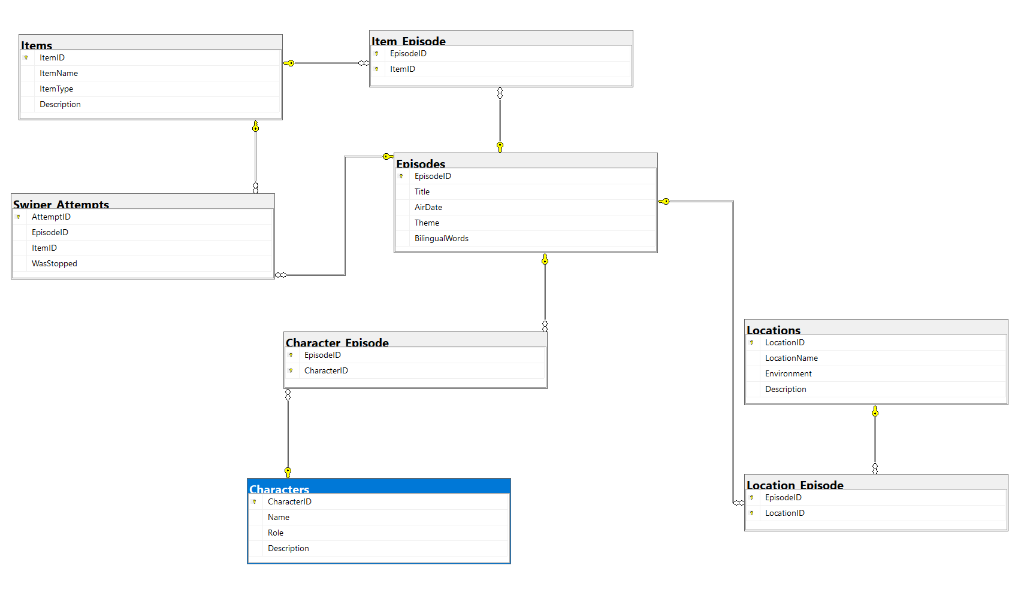

Answer the following questions

***CLO #: 2***

Q1:Riseross wants to keep track of teams and hero stats. To do so [3 + 4 = 7 Marks]

Write the following queries:

a) Create a table named Rating with the following structure:

* **RatingID** – An integer as the auto incremented **primary key**.
* **RatingDescription** – A string of at most **200 characters**.
* **Stars** – A Float between 0 and 5

b) Create a table named Character_Rating with the following structure:

* **CR_ID** – An integer as the part of **primary key**.
* **RatingID** – A **nullable** foreign key referencing the **Rating** table.
* **CharacterID** – A foreign key referencing the **Character** table.
* **Source** – IMDB or Netflix.
* **RatingDate** – A **date column**

Ensure that the appropriate constraints (PRIMARY KEY, FOREIGN KEY, CHECK, DEFAULT) are properly implemented.

***CLO #: 2***

Q2: Dora gave suggestions to enhance DB. To do so Write the following queries:

a) Add Avg rating (Decimal) to the Characters Table. *(2 Marks)*

* Ensure that the column cannot be negative or null.
* The default value should be avg from ratings table.

b) Change the column type of Avg Rating to be Float between 0 and 5. *(1 Mark)*

c) Add a computed column named “Total Episodes” in Character Table as count of episodes the character participated in. *(2 Marks)*

d) Drop the unique constraint from Character Name in Charcaters table and add it through alter statement. (1 Mark)

***CLO #: 3***

**Q3:** DML & Basic Queries [7(1+1+1+3+1) marks]

1. **Insert the following data into the** Rating **table using one insert query:** 
   * **('Excellent show, highly educational', 5.0),**
   * **('Great for kids, fun learning experience', 4.8),**
   * **('Good but could have more adventure', 4.2),**
   * **('Decent show, but a bit repetitive', 3.5),**
2. Insert following data into Charcater Rating using single insert
   * **INSERT INTO Character_Rating (RatingID, CharacterID, Source, RatingDate) VALUES**
   * **(1, 1, 'IMDB', '2024-01-15'), -- Dora rated highly on IMDB**
   * **(2, 2, 'Netflix', '2024-02-20'), -- Boots rated highly on Netflix**
   * **(3, 3, 'IMDB', '2024-03-05'), -- Map rated on IMDB**
   * **(4, 4, 'Netflix', '2024-03-10'), -- Backpack rated on Netflix**
   * **(5, 5, 'IMDB', '2024-04-12'), -- Swiper got mixed reviews on IMDB**
3. Delete all Ratings that are not given to any character.
4. Update avg rating of character table using one update statement based on Character Rating table avg.
5. Change location of all even ID episodes to be the location of odd ID episodes.

***CLO #: 3***

**Q4:** DQL & Queries [20 marks]

**a) [3 Marks]** Retrieve the First and Last Location Visited in Each Episode.

**b) [3 Marks]** Show Total Quests Per Explorer & Average Across All Explorer.

**c) [4 Marks]** Find Quests Where Dora, Boots, and Backpack did not Participate.

**d) [5 Marks]** Find the Episode Where Swiper Attempted to Steal the Most Items.

**e) [5 Marks]** Find Episodes Where Swiper Was Stopped More Than 2 Times**.**